Web Download Flavors Configuration Instructions

Introduction
Some installation file sets are very large, and thus inconvenient to download over the web. They often contain superfluous software, which most users wouldn’t need. For example, including Windows Installer 3.1, because it is a required prerequisite to some other software in the set, is superfluous to the many users who already have it. It would be better to also provide a subset of the files without Windows Installer, and an easy way for users to choose which set of files to download. The Web Download Flavors Configuration tool is used to adapt an existing master installer XML file into one or more of these download flavors. It can generate a 7-zip archive of the file set for each flavor (complete with a Master Installer that understands it is a reduced file set), and a new XML file defining all the flavors, which plugs into the WhichDownload.htm web page (coupled with the TestPresence ActiveX control), to tell users which flavor is best for their computer.
This document explains how to use the Web Download Flavors Configuration tool. The tool runs on Microsoft Internet Explorer version 7 or higher. The tool itself has a user interface defined via the referenced ConfigureWebDownloads.xsl file.
The interface acts like a configuration wizard, with each screen having Next and Previous buttons. You should fill out the details on each page, and then press the Next button, until you get to the end.

0. Initialization

Make sure you have updated the files from the Subversion repositories Master Installer and Products, before launching the configuration tool. If you haven’t previously done so, run the InitUtils.exe application in the Master Installer’s Utils subfolder.
The tool is launched by double clicking on an existing XML master installation configuration file. However, it may first need editing to make sure it uses the correct style sheet. Make sure the second line in the XML reads as follows:
<?xml-stylesheet type="text/xsl" href="ConfigureWebDownloads.xsl" ?>
Also, make sure that a copy of the ConfigureWebDownloads.xsl file (from the Master Installer’s Utils subfolder) is in the same folder as the XML file.

When the tool is first run, the browser shows the following security warning:

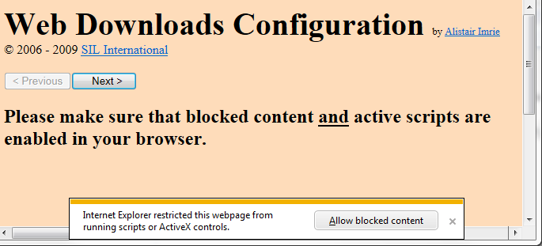

Click on Allow Blocked Content. You will then get the following message box:

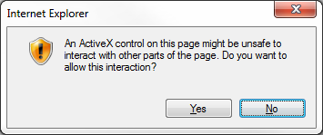
Click Yes.

You will then see the Flavor Names Setup page.

1. Flavor Names Setup page

The Flavor Names Setup page looks something like this:

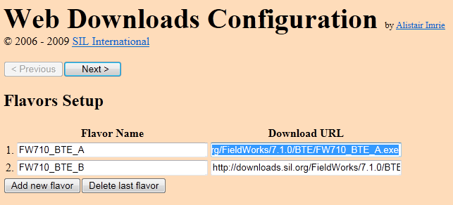

Type in the name for each flavor you want in the boxes provided, and also the actual URL needed to download the flavor (which is where it will be only after you have posted it on the server, obviously!) If you need an extra row, press the Add new flavor button. If you want to remove a row, press the Delete last flavor button. The flavor names you enter here will be the ones seen by users.

2. Flavor Configurations page

The Flavor Configurations page looks something like this:

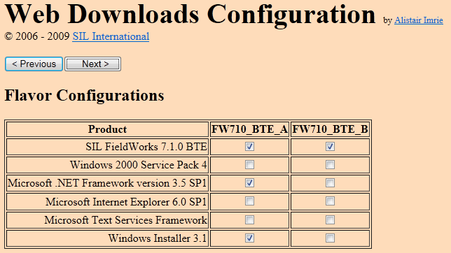

In the Product column are listed all the products that ought to ship with the bundle. To the right is a column for each flavor you named on the previous screen. You can select or clear products for each flavor. When you clear a product, it is omitted from the specified flavor. If a user is using that flavor and needs the missing product, the master installer will issue an appropriate error message.

3. Ready to go page

The Ready to go page looks something like this:

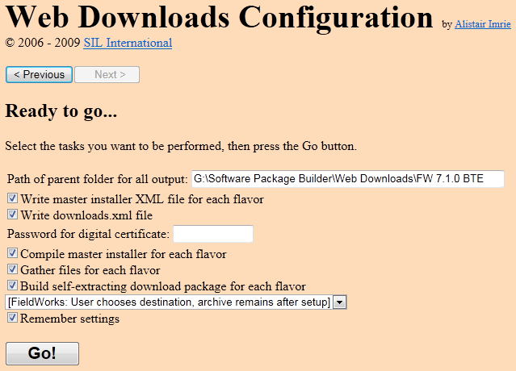

This page provides options for how much of the output process you want.
Path of parent folder for all output: Enter into this box the path of the parent folder for all output, which will contain all the flavors.
Write master installer XML file for each flavor: Check this box to have the tool write out the XML files defining each flavor’s master installer.
Write downloads.xml file: Check this box to have the tool write out the downloads.xml file, which defines all the flavors in a way that can be used by the WhichDownload.htm web page.
Password for digital certificate: Various files will be signed by the output process, and this box is for the password of the SIL digital certificate, which will be passed to the signing process each time, saving having to type in the password each time. The files that are signed are master installers, .msi installers, and download packages.
Compile master installer for each flavor: Check this box to have the tool compile the master installer for each flavor. Each master installer will differ only in its expectations of which software products it can install itself.
Gather files for each flavor: Check this box to have the tool copy files from the software products repository to the folder for each flavor.
Build self-extracting download package for each flavor: Check this box to have the tool compress each flavor’s bundle of files into a self-extracting 7-zip archive. Select an option in the accompanying combo box to configure how the archive will self-extract.
Remember settings: Check this box to have the tool save the current user-settings in the form of a web bot that will automatically apply the same settings should the tool be run again (by double-clicking on the same master installer XML file). Note that the digital certificate password will not be saved, and the web bot will not press the “Go” button.
Go! Press this button to start the activities selected above.

How to set up a website with the output from this tool.

When you have run all the activities in the last page, you will end up with the following in the root folder for all output defined on the last page:
- A folder for each flavor. This contains the raw file set for the flavor. This is not needed on the web server, but is useful for maintenance/archiving purposes.
- An XML file for each flavor. This defines the master installer for the flavor. This is not needed on the web server, but is useful for maintenance/archiving purposes.
- A .7z file for each flavor. This is not needed on the web server, but is a 7-zip archive of the raw file set.
- An .exe file for each flavor. This is needed on the web server, and is independent of the other files. It is a self-extracting 7-zip archive of the raw file set.
- An .md5.txt file for each flavor. Inside the file is the MD5 hash value for the corresponding .exe file. It is a good idea to report this value for each flavor on the web page, so that users can verify that their download was successful.
- A .config.txt file for each flavor. This contains the 7-zip self-extraction configuration.
- A Downloads.xml file. This is needed on the web server, and must go in the same folder as the WhichDownload.htm file. (See below.)
- A Downloads.txt file. This contains a summary of each flavor’s download package filename, size, MD5 hash, and download URL. This is suitable for copying into an email to notify people of the existence of the packages on the web server.

You also need a copy of the WhichDownload.htm and TestPresence.cab files, located in the TestPresence Web Control\Web Page Tests folder of the Master Installer repository. The TestDownloads.htm file must be edited so that the CODEBASE definition of the TestPresenceWebControl1 object points to the place where you will store the TestPresence.cab file.

